Question 1

**<https://youtu.be/gd9aTazw2kE>**

**Step 1:**

Login to Google cloud.

<https://console.cloud.google.com/>

Project🡪 New Project🡪Project Name(**Assignment2**)🡪Create(Under Organisation & Location iitj.ac.in)

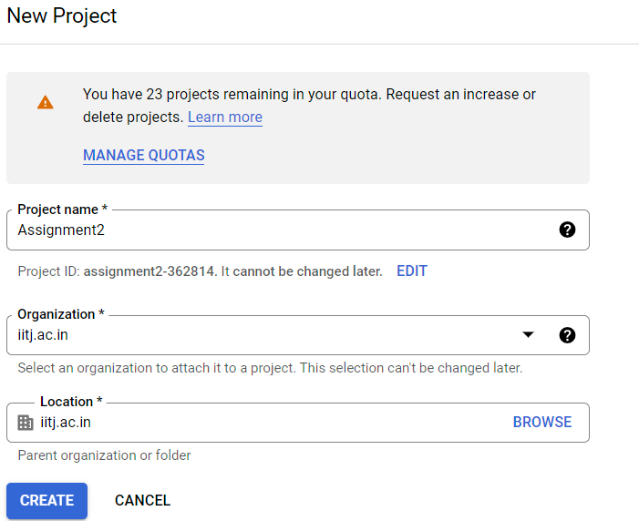

Step 2:

**As I explained in the question1 I did exactly the same method for creating VM inside GCP Cloud.**

**Step 2:**

* Click the Navigation bar menu and select Compute engine🡪 VM Instances🡪 Create Instance
* Provide instance name as m20aie252-sdb
* Selected Region and zone as a default value(us-central1)
* In Machine configuration selected machine type as e2-medium(2 vCPU, 4GB Memory)
* Boot disk section I changed Operating System to ubuntu and version 20.04 LTS x86/64(10GB Size)
* In Firewall section checked allow http/https traffic both

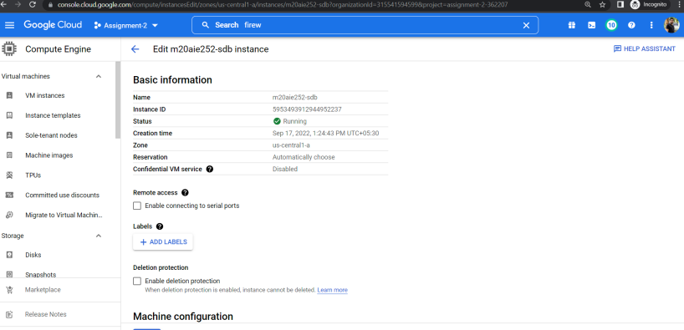

Step 3:

To configured the SQL Server inside GCP VM ubuntu 20.04, I followed below steps-

* Importing public repository

***wget -qO- https://packages.microsoft.com/keys/microsoft.asc | sudo apt-key add –***

* For register sql server

***sudo add-apt-repository "$(wget -qO- <https://packages.microsoft.com/config/ubuntu/20.04/mssql-server-preview.list>)"***

* Direct install sql server by

***sudo apt-get update***

***sudo apt-get install -y mssql-server***

* Choosed the Developer edition
* For password configuration

***sudo /opt/mssql/bin/mssql-conf setup***

* Check service status

***systemctl status mssql-server --no-pager***

Step 4:

* Command line install for linux

***sudo apt-get update***

***sudo apt install curl***

* The same way importing GPG keys as above

***curl https://packages.microsoft.com/keys/microsoft.asc | sudo apt-key add –***

* Ubuntu repository registration

***curl https://packages.microsoft.com/config/ubuntu/20.04/prod.list | sudo tee /etc/apt/sources.list.d/msprod.list***

* Install microosft ODBC DRIVER for sql server using unixODBC package.

***sudo apt-get update***

***sudo apt-get install mssql-tools unixodbc-dev***

* Update latest version of ms sql server

***sudo apt-get update***

***sudo apt-get install mssql-tools***

* Add the path inside environmental PATH variable

***echo 'export PATH="$PATH:/opt/mssql-tools/bin"' >> ~/.bash_profile***

Step 5:

Localhost set username and password and create database tables.

***sqlcmd -S localhost -U sa -P '123456'***

* For creating new database-

***CREATE DATABASE TestDB***;

* Create new table-

***CREATE TABLE dbo.Inventory (***

***id INT, name NVARCHAR(50),***

***quantity INT***

***);***

* Insert query for new record-

***INSERT INTO dbo.Inventory VALUES (1, 'banana', 150);***

***INSERT INTO dbo.Inventory VALUES (2, 'orange', 154);***

* For execute SQL statements-

***GO***

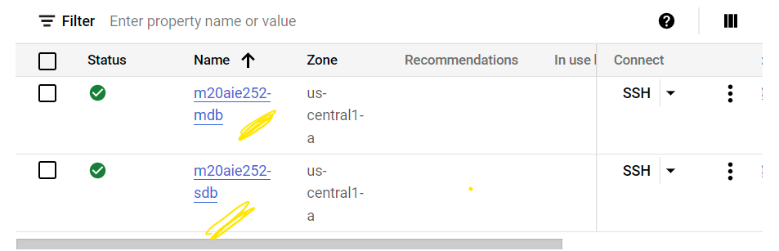

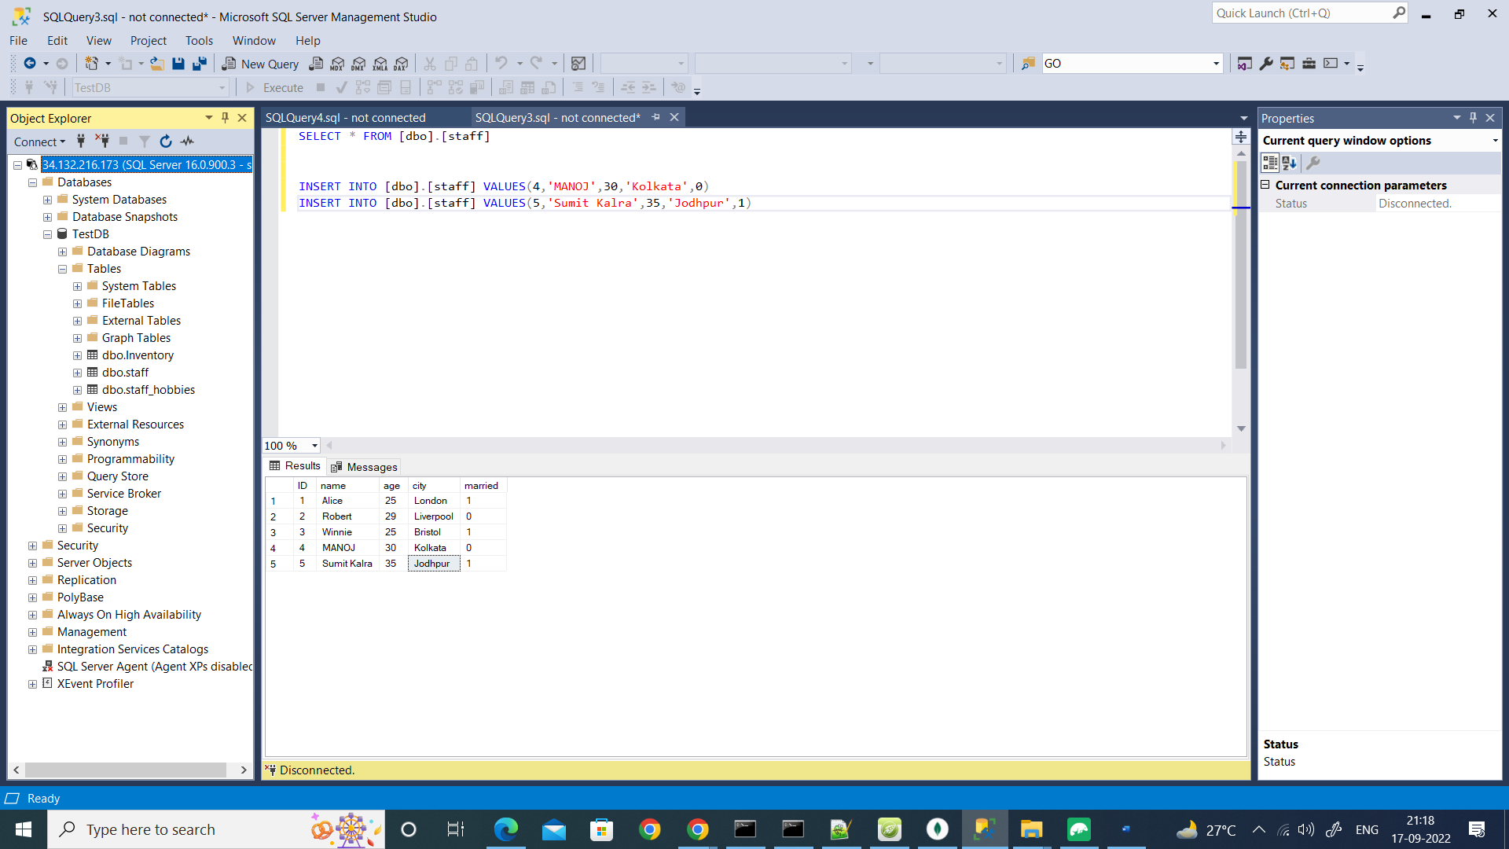

* Connected SQL server using Sql Server management studio(Host Ip is the external Ip)
* I set the Firewall rule having port 1433 inside gcp firewall

